**Aim:** To understand the process of convolution over the image and apply over the classification problem

**IDE:** Google Colab

**Theory:**

Convolutional Neural Networks (CNN) are complex feed forward neural networks. CNNs are used for image classification and recognition because of its high accuracy There are three types of layers in a convolutional neural network: i. Convolutional layer ii. Pooling layer iii. Fully connected layer Each of these layers has different parameters that can be optimized and performs a different task on the input data.

**What is Pooling Layer?**

Pooling layer is responsible for reducing the spatial size of the Convolved Feature. This is to decrease the computational power required to process the data through dimensionality reduction. There are two types of Pooling i. Average Pooling. ii. Max Pooling Max Pooling returns the maximum value from the portion of the image covered by the Kernel. On the other hand, Average Pooling returns the average of all the values from the portion of the image covered by the Kernel. Max Pooling also performs as a Noise Suppressant. It discards the noisy activations altogether and also performs de-noising along with dimensionality reduction. On the other hand, Average Pooling simply performs dimensionality reduction as a noise suppressing mechanism. Hence, we can say that Max Pooling performs a lot better than Average Pooling.

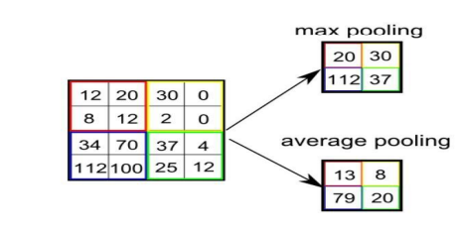

**What is Convolutional Layer?**

Convolutional layers are the major building blocks used in convolutional neural networks. A convolution is the simple application of a filter to an input that results in an activation. Repeated application of the same filter to an input results in a map of activations called a feature map, indicating the locations and strength of a detected feature in an input, such as an image. A convolutional layer contains a set of filters whose parameters need to be learned. The height and weight of the filters are smaller than those of the input volume. Each filter is convolved with the input volume to compute an activation map made of neurons.

**What is Fully Connected Layer?**

A fully connected layer that takes the output of convolution/pooling and predicts the best label to describe the image We have three layers in the full connection step i. Input layer ii. Fully-connected layer iii. Output layer

**Input Layer**: It takes the output of the previous layers, “flattens” them and turns them into a single vector that can be an input for the next stage.

**Fully Connected Layer**: It takes the inputs from the feature analysis and applies weights to predict the correct label.

**Output Layer**: It gives the final probabilities for each label.

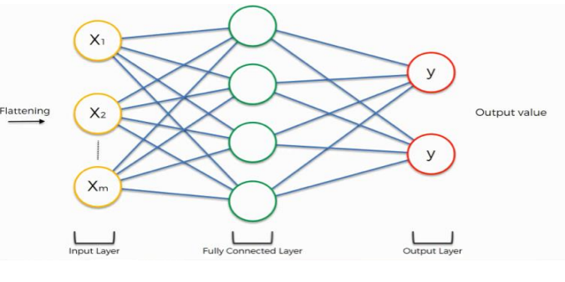

**ReLU Layer**: ReLU is an activation function. Rectified Linear Unit (ReLU) transform function only activates a node if the input is above a certain quantity, while the input is below zero, the output is zero, but when the input rises above a certain threshold, it has a linear relationship with the dependent variable. The main aim is to remove all the negative values from the convolution. All the positive values remain the same but all the negative values get changed to zero.

**Methodology:**

1. Load the basic libraries and packages
2. Load the dataset
3. Analyse the dataset
4. Normalize the data
5. Pre-process the data
6. Visualize the Data
7. Write the CNN model function
8. Write the Cost Function
9. Write the Gradient Descent optimization algorithm
10. Apply the training over the dataset to minimize the loss
11. Observe the cost function vs iterations learning curve

**Program (Code):**

To be attached with

**Results:**

To be attached with

1. Training dataset
2. Model summary
3. Training and validation accuracy w.r.t epochs before regularization
4. Training and validation loss w.r.t epochs before regularization
5. Training and validation accuracy w.r.t epochs after regularization
6. Training and validation loss w.r.t epochs after regularization
7. Original v/s predicted labels for correct predicted observations
8. Original v/s predicted labels for incorrect predicted observations

**Pre Lab Exercise:**

1. What is Convolution process? Explain giving example.

________________________________________________________________________________________________________________________________________________________________________________________________________________________

1. What are different layers in CNN model?

________________________________________________________________________________________________________________________________________________________________________________________________________________________

1. What is the requirement of the pooling layer in the CNN model?

________________________________________________________________________________________________________________________________________________________________________________________________________________________

1. What is the requirement of the use of ReLU activation function after convolution step?

________________________________________________________________________________________________________________________________________________________________________________________________________________________

**Observation and Result Analysis:**

1. Nature of the dataset

________________________________________________________________________________________________________________________________________________________________________________________________________________________________________________________________________________________________

1. Training Process without regularization

________________________________________________________________________________________________________________________________________________________________________________________________________________________________________________________________________________________________

1. After regularization in the training Process

________________________________________________________________________________________________________________________________________________________________________________________________________________________________________________________________________________________________

1. Observation over the Learning Curves

________________________________________________________________________________________________________________________________________________________________________________________________________________________

**Post Lab Exercise:**

1. Why CNN is preferred over ANN for images

________________________________________________________________________________________________________________________________________________________________________________________________________________________

## Can CNN be applied over Text data? If yes, then how. If no, then why?

________________________________________________________________________________________________________________________________________________________________________________________________________________________

1. What is the role of dropout layer?

________________________________________________________________________________________________________________________________________________________________________________________________________________________

1. What will happen if maxpooling is replaced with minpooling?

________________________________________________________________________________________________________________________________________________________________________________________________________________________